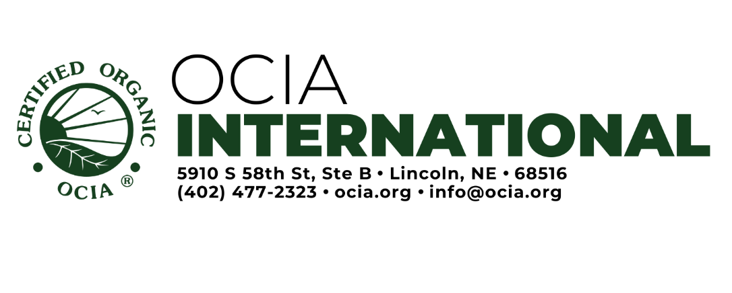

EU (EC), UK or RTPO Seed Exemption Request

We are requesting prior authorization to use non-organic seed or vegetative propagated material for crops to be certified to EU, UK Equivalency or RTPO, because the type and variety of seed and/or vegetative propagated material we want to use is not commercially available on the market as organic. We understand the seed exemption can only be granted for one growing season, must be obtained before planting the crop, and must be requested again if non-organic seed/vegetative propagated material is requested for use in a future season. I understand that non-organic seedlings for annual crops cannot be authorized.

- Common Name (type) and variety of seed/vegetative material:
- Scientific Name (Latin name) of seed/vegetative material:
- Quantity of Seed/vegetative material (by weight or number of plants):

- Is this seed/material verified as non-GMO?
- Is this seed/material available as organic or in-conversion?

- Reason exemption is requested (see standard below):

- Origin (provider):

- Does a different program from EU certify the seed/vegetative materials as organic?
Attached with request:
Seed Search with specific companies contacted
Other documentation to show seed isn’t commercially available (catalog, brochure, etc)
Documentation showing that seed/vegetative material is from a non-GMO source
Documentation showing any seed treatments for the seed/vegetative material.
Other (tags, purchase orders, organic certificate, etc):

Signature of Operator: Date:

Operation Name: Operation Number:

CDT Decision: Verified Compliant Not Compliant
CDT Comments:

CDT Member: | Date (M/D/Y):

