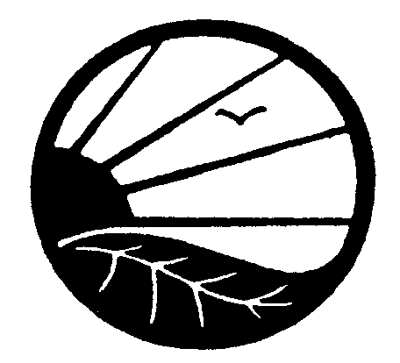
Modified Label Affidavit
Instructions: Please fill out this affidavit if you are submitting a label that has changed for your organically certified product. Please provide this form along with copies of the draft labels. New private label brands should be submitted via the Additional Processed Product/Production Line/Program Affidavit, not this form. Please note that labels should not be printed until they are approved by OCIA. Labels that are printed prior to approval will need to be updated if any errors or compliance issues are found.
General Information |  |  |  |  |  |  | DATE (M/D/Y):

CONTACT INFORMATION
Operation Name:
Operation Number:
Check ALL the programs for which the product will be represented. Please remember that the label(s) may only be used to represent programs for which the product is certified for/verified to. For an equivalency to be added (e.g. US-Canada, Canada-EU), a draft label in compliance with the destination’s labeling requirements must be provided with the request.
National Organic Program (NOP) ^^^
US-Canada Equivalence Arrangement
Canadian Organic Regime (COR)^^
Ley de Productos Orgánicos de México (LPO)
EC (EU)***
RTPO (Peru)
UK***
Japan Agricultural Standard (JAS)
USDA-MAFF (JAS Equivalency)**
US-EU Equivalence Arrangement**
US-UK Equivalence Arrangement**
US-Korea Equivalency Arrangement**
US-Switzerland Equivalency Arrangement**
US-Taiwan Equivalence Arrangement**
Canada-Costa Rica Equivalency Arrangement^
Canada-EU Equivalency Arrangement^
Canada-UK Equivalency Arrangement^
Canada-Japan Equivalence Arrangement^
Canada-Switzerland Equivalency Arrangement^
Canada-Taiwan Organic Equivalency Arrangement^
Canada-Mexico Organic Equivalency Arrangement+
OCIA International Standards
OCIA Shade Grown Coffee
**Only available if operation is in the United States. ^Only available to operations located in Canada.
***Not available to U.S. and Canadian-based operations cannot receive EC (EU).
^^ Not available to U.S. operations. ^^^Not available to Canadian operations.
+Only available to operations in Canada or Mexico
Label Information
The following finished labels will be used on my organic products:
Product and Name Brand | Weight(s)/Size(s) | Label type |  | Requested Labeling Category
Product and Name Brand | Weight(s)/Size(s) | Retail | Non-retail | “100 % Organic” | “Organic” | “Made with Organic…”/”% Organic” |  | Indicates Organic Ingredients
The following information must be included with the Modified Label Affidavit for each modified label submitted:
- OCIA Organic Product Ingredients checklist (if changes to product have been made)
- Copy of the revised label (or a draft or sketch of the proposed revised label if not completed)
Please explain the changes that have been made to the label(s):

I would like this/these revised label(s) to be approved for my certified organic product(s). I affirm that all statements made in this Affidavit are true, correct, and complete. I also affirm that I understand the standards/regulations for the specific program(s) that the label(s) represent(s).

Authorized Representative Printed Name:
Signature: Date (M/D/Y):
NOTE: The Modified Label Affidavit must be signed by the legal representative of the operation. These documents shall be considered executed by the operation when signed electronically. To sign electronically please use the following format /FULL NAME (FIRST MIDDLE INITIAL LAST)/. Example: /John A. Smith/ Failure to electronically sign these forms will delay processing of the operation’s request.

